1. Art Browser is coming up twice in **About Us** page and **Join Us** page before logging in

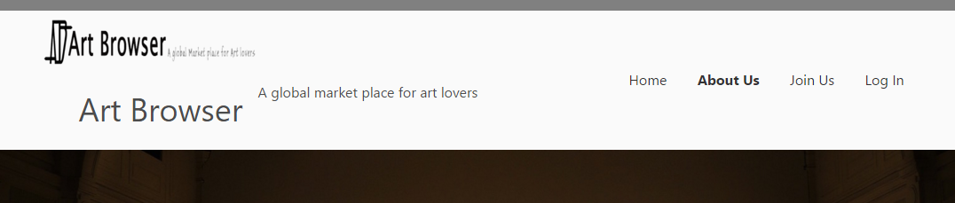

1. In the home page “HOW THE APP WILL WORK” as per the below screenshot

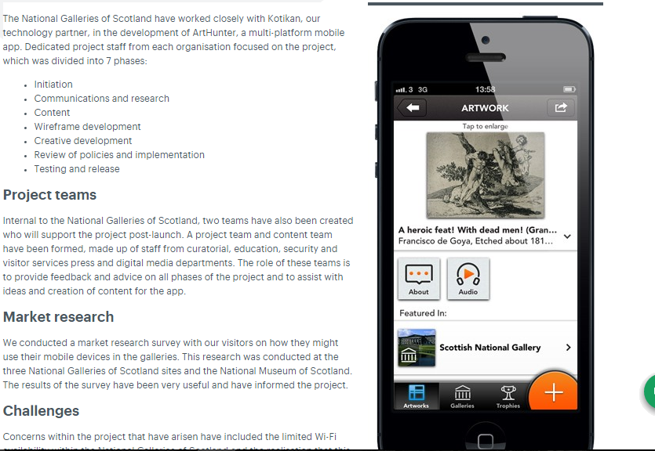

1. We need to Terms and Conditions in Join Us page before submitting the form as in the below link

<http://www.the-art-of-web.com/html/html5-checkbox-required/>

1. As discussed over IM, we need show the Pro’s of Premium membership in **Join Us** Page. Just keep heading as “Premium Subscription” and keep some dummy text for 3 or points.
2. Use the given fonts in the web site, use appropriate fonts for headings and normal text <https://github.com/sveinbjornt/lemur2013/tree/master/assets/fonts/Brandon%20Grotesque>
3. We do have some changes after logging in to the portal, we will have a call and close them out